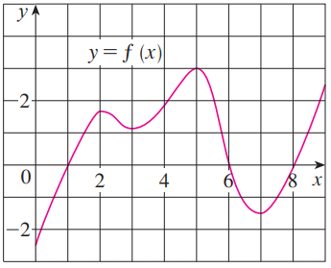
- The graph of a function is shown at the right. Assume that the domain of is . Use the graph of the function to help answer the following questions.
- On what intervals is f increasing? Decreasing?

- At what values of x does f have a local maximum? Local minimum?

- Estimate on what intervals is f concave upward? Concave downward?

- Estimate the x-coordinate(s) of the point(s) of inflection.

- Consider the function . Without the use of a graph, determine each of the following.

- On what intervals is f increasing? Decreasing?

- At what values of x does f have a local maximum? Local minimum?

- On what intervals is f concave upward? Concave downward?

- State the x-coordinate(s) of the point(s) of inflection.

- Suppose the derivative of a function is .
- Determine where is increasing and decreasing, if you assume that is defined on .
- Determine at what x-values has local extrema.

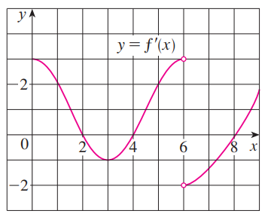
- The graph of the derivative of is shown below.
- On what intervals is f increasing? Decreasing?

- At what values of x does f have a local maximum? Local minimum?

- On what intervals is f concave upward? Concave downward?

- State the x-coordinate(s) of the point(s) of inflection.

- Use the information that you have to create a possible picture of .

- Find the local maximum and minimum values of using both the First and Second Derivative Tests.

- Suppose that , , and and for all x.
- Sketch a possible graph for f.

- How many solutions does the equation have? Why?

- Is it possible that ?

- Consider the function .
- Determine the exact value of x at which increases most rapidly. Hint: Something is being maximized here. What function are we trying to maximize?

- Reflect on your work in part (a). What does your work here imply about the significance of inflection points?

- Consider the function , where a, b, c, & d are real numbers with .
- Prove that has exactly one inflection point.

- Prove that if has 3 x-intercepts, then the inflection point occurs at the average value of the intercepts.

- Use the result to from part (b) to find the inflection point of the cubic polynomial , and check your result by finding the inflection points of using the second derivative.

- For what value c is the function increasing on .

